**Master Functional Document**

|  |  |
| --- | --- |
| **Application** | NGERP - Centra |
| **Service Bundle** | Master Management |
| **Service** **Request** | Change Audit |

**Description:**

In the Compiere (NGERP – Centra) application, the Change Audit screen is used to display all logs of updates or changes made to any transaction. This screen stores these changes for audit purposes.

Workflow Process:

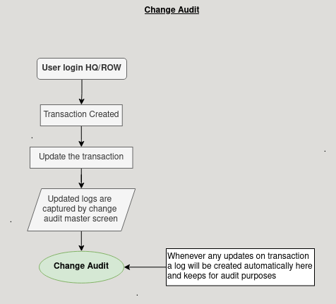

**Business Rules:**

* The Change Audit screen will be available in both HQ and ROW environments.
* Users will not be able to edit the records in the Change Audit screen. It is a view-only screen for tracking changes.
* The system will automatically create records in the Change Audit screen whenever there are updates to transactions, ensuring all changes are logged without user intervention.
* Every time someone changes something in the system (like updating a record), the system must save a log with the details of what was changed, who made the change